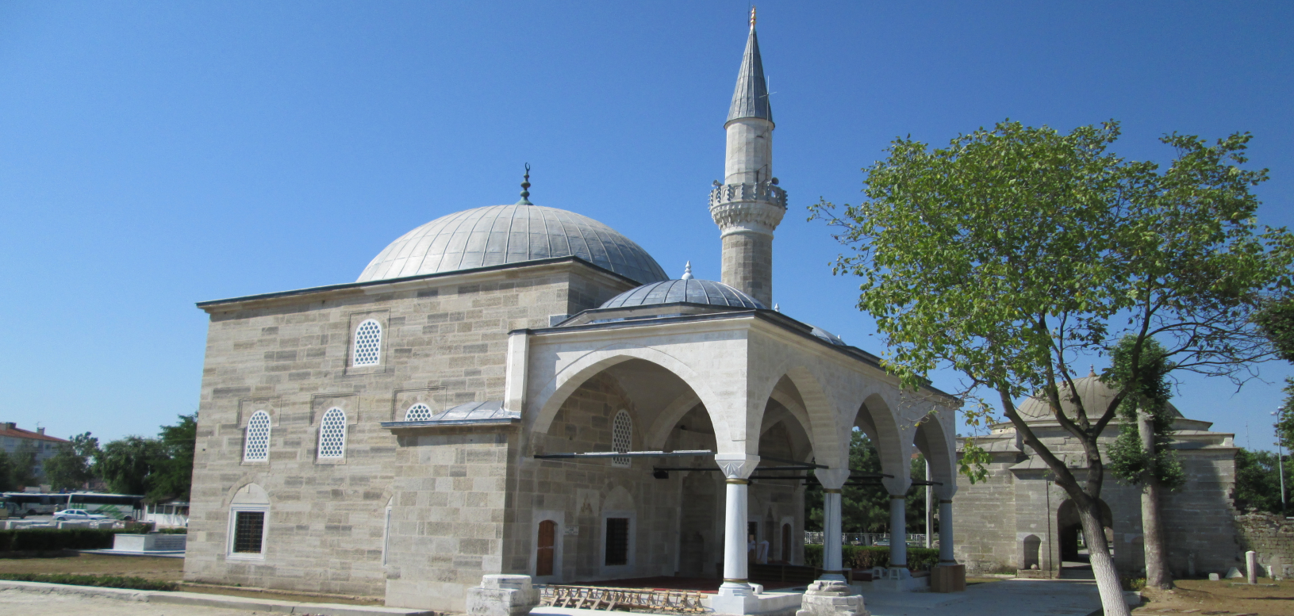

HAVSA İLÇE MÜFTÜLÜĞÜ
Miladi 2020 / Hicri 1441 YILI RAMAZAN İMSAKİYESİ
HİCRİ AY MİLADİ AY GÜN İMSAK GÜNEŞ ÖĞLE İKİNDİ AKŞAM YATSI
01 RAMAZAN 24 NİSAN CUMA 04 35 06 12 13 16 17 04 20 10 21 40
02 RAMAZAN 25 NİSAN CUMARTESİ 04 34 06 11 13 16 17 04 20 11 21 41
03 RAMAZAN 26 NİSAN PAZAR 04 32 06 09 13 16 17 05 20 12 21 43
04 RAMAZAN 27 NİSAN PAZARTESİ 04 30 06 08 13 15 17 05 20 13 21 44
05 RAMAZAN 28 NİSAN SALI 04 28 06 07 13 15 17 05 20 14 21 46
06 RAMAZAN 29 NİSAN ÇARŞAMBA 04 26 06 05 13 15 17 05 20 15 21 47
07 RAMAZAN 30 NİSAN PERŞEMBE 04 24 06 04 13 15 17 06 20 16 21 49
08 RAMAZAN 01 MAYIS CUMA 04 22 06 03 13 15 17 06 20 17 21 50
09 RAMAZAN 02 MAYIS CUMARTESİ 04 20 06 01 13 15 17 06 20 18 21 52
10 RAMAZAN 03 MAYIS PAZAR 04 19 06 00 13 15 17 07 20 19 21 54
11 RAMAZAN 04 MAYIS PAZARTESİ 04 17 05 59 13 15 17 07 20 20 21 55
12 RAMAZAN 05 MAYIS SALI 04 15 05 57 13 14 17 07 20 21 21 57
13 RAMAZAN 06 MAYIS ÇARŞAMBA 04 13 05 56 13 14 17 08 20 23 21 58
14 RAMAZAN 07 MAYIS PERŞEMBE 04 11 05 55 13 14 17 08 20 24 22 00
15 RAMAZAN 08 MAYIS CUMA 04 10 05 54 13 14 17 08 20 25 22 01
16 RAMAZAN 09 MAYIS CUMARTESİ 04 08 05 53 13 14 17 08 20 26 22 03
17 RAMAZAN 10 MAYIS PAZAR 04 06 05 52 13 14 17 09 20 27 22 05
18 RAMAZAN 11 MAYIS PAZARTESİ 04 05 05 50 13 14 17 09 20 28 22 06
19 RAMAZAN 12 MAYIS SALI 04 03 05 49 13 14 17 09 20 29 22 08
20 RAMAZAN 13 MAYIS ÇARŞAMBA 04 01 05 48 13 14 17 10 20 30 22 09
21 RAMAZAN 14 MAYIS PERŞEMBE 04 00 05 47 13 14 17 10 20 31 22 11
22 RAMAZAN 15 MAYIS CUMA 03 58 05 46 13 14 17 10 20 32 22 12
23 RAMAZAN 16 MAYIS CUMARTESİ 03 56 05 45 13 14 17 11 20 33 22 14
24 RAMAZAN 17 MAYIS PAZAR 03 55 05 44 13 14 17 11 20 34 22 15
25 RAMAZAN 18 MAYIS PAZARTESİ 03 53 05 44 13 14 17 11 20 35 22 17
26 RAMAZAN 19 MAYIS SALI 03 52 05 43 13 14 17 11 20 36 22 18
27 RAMAZAN 20 MAYIS ÇARŞAMBA 03 50 05 42 13 14 17 12 20 37 22 20
28 RAMAZAN 21 MAYIS PERŞEMBE 03 49 05 41 13 14 17 12 20 38 22 21
29 RAMAZAN 22 MAYIS CUMA 03 48 05 40 13 14 17 12 20 39 22 23
30 RAMAZAN 23 MAYIS CUMARTESİ 03 46 05 39 13 14 17 13 20 40 22 24

19 Mayıs Salı Kadir Gecesi 2020 Yılı Fitre Bedeli
24 Mayıs Pazar Ramazan Bayramının 1.Günü 27,00-TL
Bayram Namaz Vakti: 06:21

